**PROJECT REPORT**

on

**Travel Booking System**

under

Professional Training (PBL) (21BSCS24C05)

**Submitted in partial fulfilment of the requirement**

**for the award of the degree**

**in**

**B.Sc. (Hons.) Computer Science/Specialization in CS/DS/AIML**

**Submitted by**

**Patel Zalak Bipinkumar, 20220701020**

**Under the guidance of**

**Prof. Rama M. Maliya**

**Prof. Sanjay Ajani**

**Unitedworld School of Computational Intelligence (USCI)**



**KARNAVATI UNIVERSITY**

**UVARSAD-ADALAJ, GANDHINAGAR**

**April - 2024**

Contents

ABSTRACT 2

INTROUDCTION 3

TECHNOLOGY USED 3

Frontend: 3

Backend: 6

FUNCTIONALITIES 8

BENEFITS 9

IMPLEMENTATION 9

CONCLUSION 11

Oracle Academy Certificates 12

Course Certificate 12

Cumulative Exam Certificate 13

# ABSTRACT

The main goal of this project is to implement an online booking Portal of travellers to ease the work of tour guides to maintain travelling records of guests which benefits them to store information of tourist easily in database. The main focus of this project is on successful database storage with efficient connectivity. This project aims to connect frontend and backend which helps store data efficiently. By use of an online platform that smoothly combines Node.js, HTML, JavaScript, and MongoDB, users may travel the world and explore a wide range of locations and lodging options from the ease of their own devices. The main feature of the system is its intuitive design, which invites users to examine carefully chosen trip possibilities based on their interests. Users explore a universe of options, from familiar places to exotic escapes, with every click opening up a new experience. The Travel Booking System's extensive customization features, which enable customers to customize every element of their itinerary, are one of its best features. From deciding on preferred lodging options to defining departure dates and itinerary, tourists.

# INTROUDCTION

In this project of Travel Booking System, I have used Html and JavaScript in Frontend to develop Web page. Then I have used MongoDB in backend to store the database of the input entered in frontend. With the help of node.js I have done connectivity between frontend and backend that is Html code and MongoDB so when I enter the data from web page it can be reflected into database od mongodb which is beneficial as updation and alteration can be code easily and data can be stored and used for further needs also.

# TECHNOLOGY USED

## Frontend:

For Frontend technology Html and JavaScript is used to develop a web page.

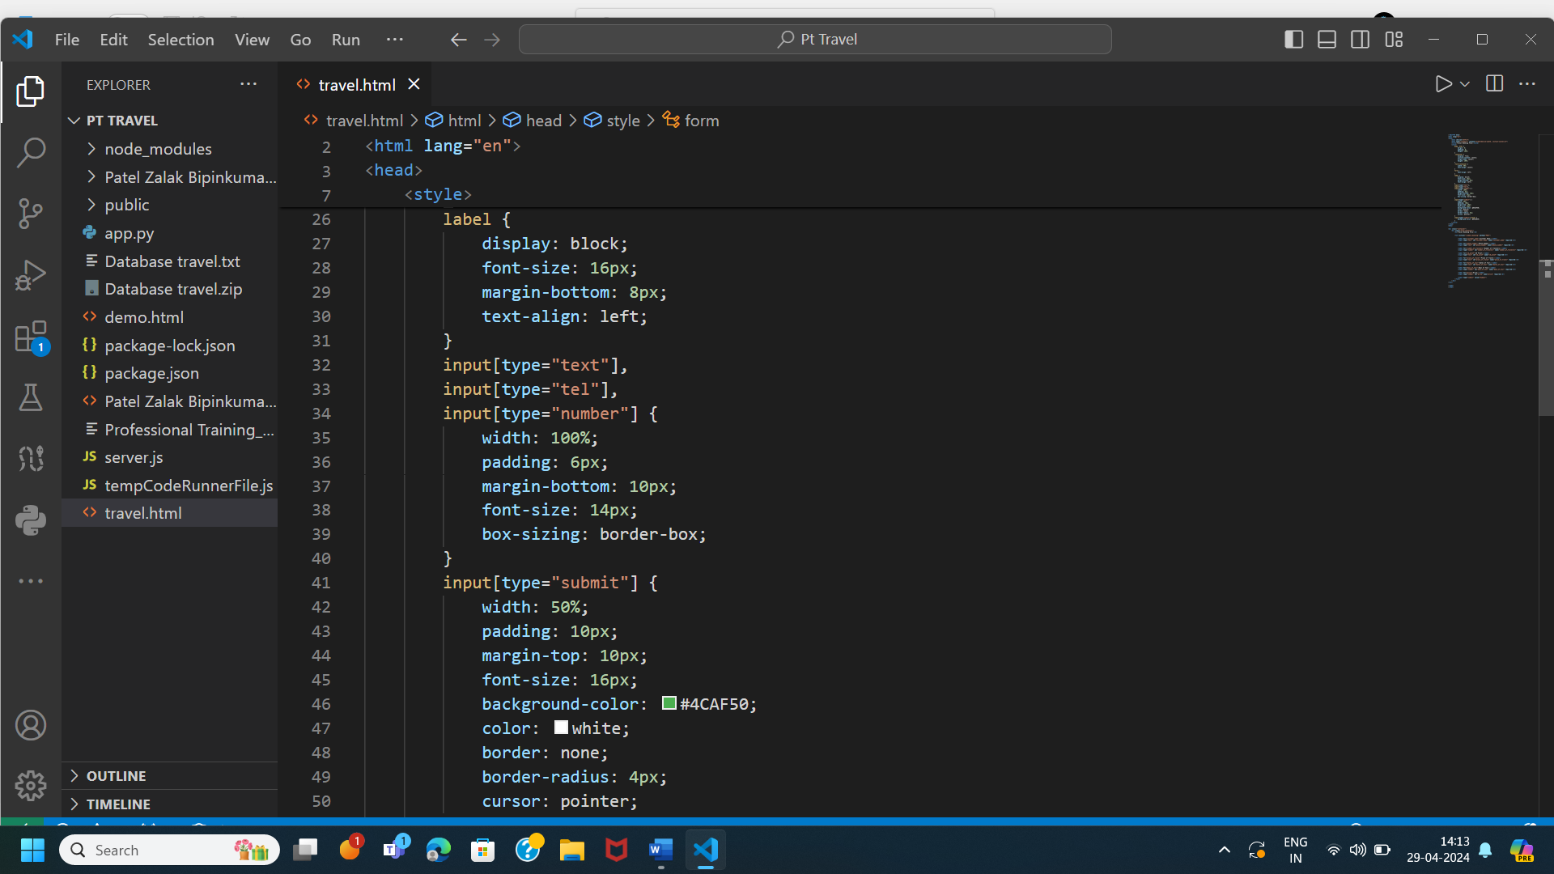

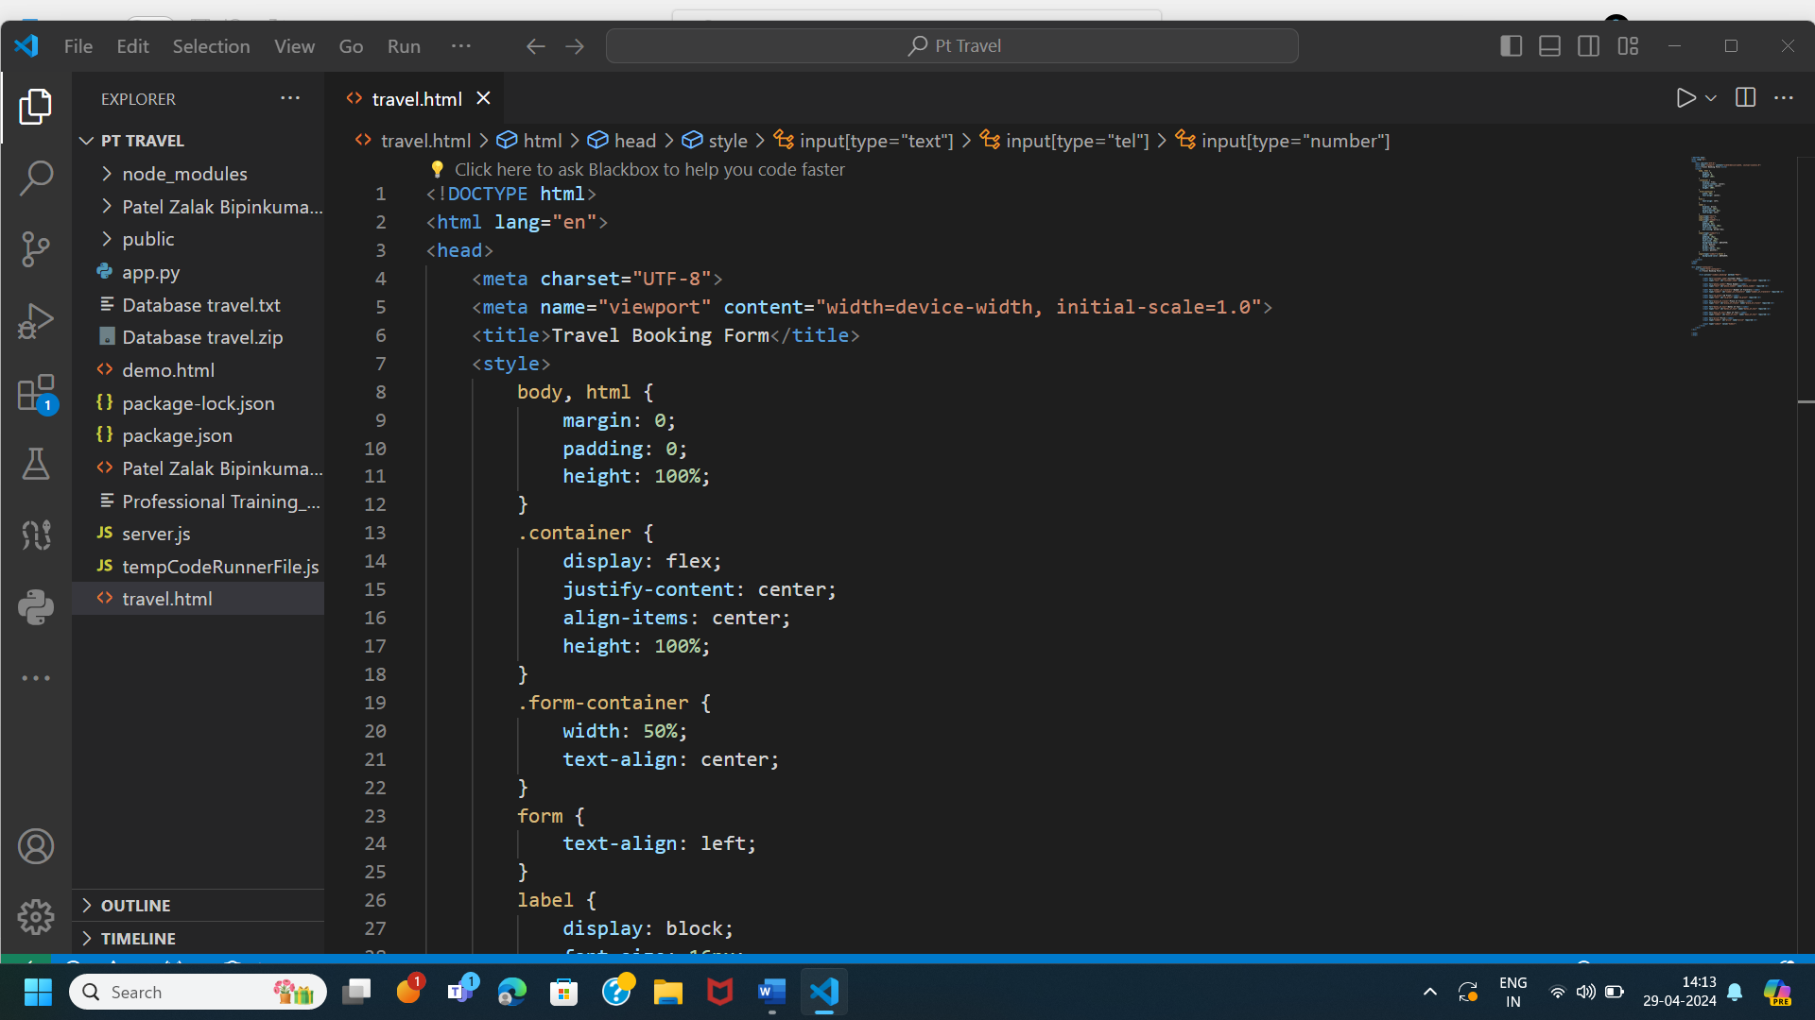

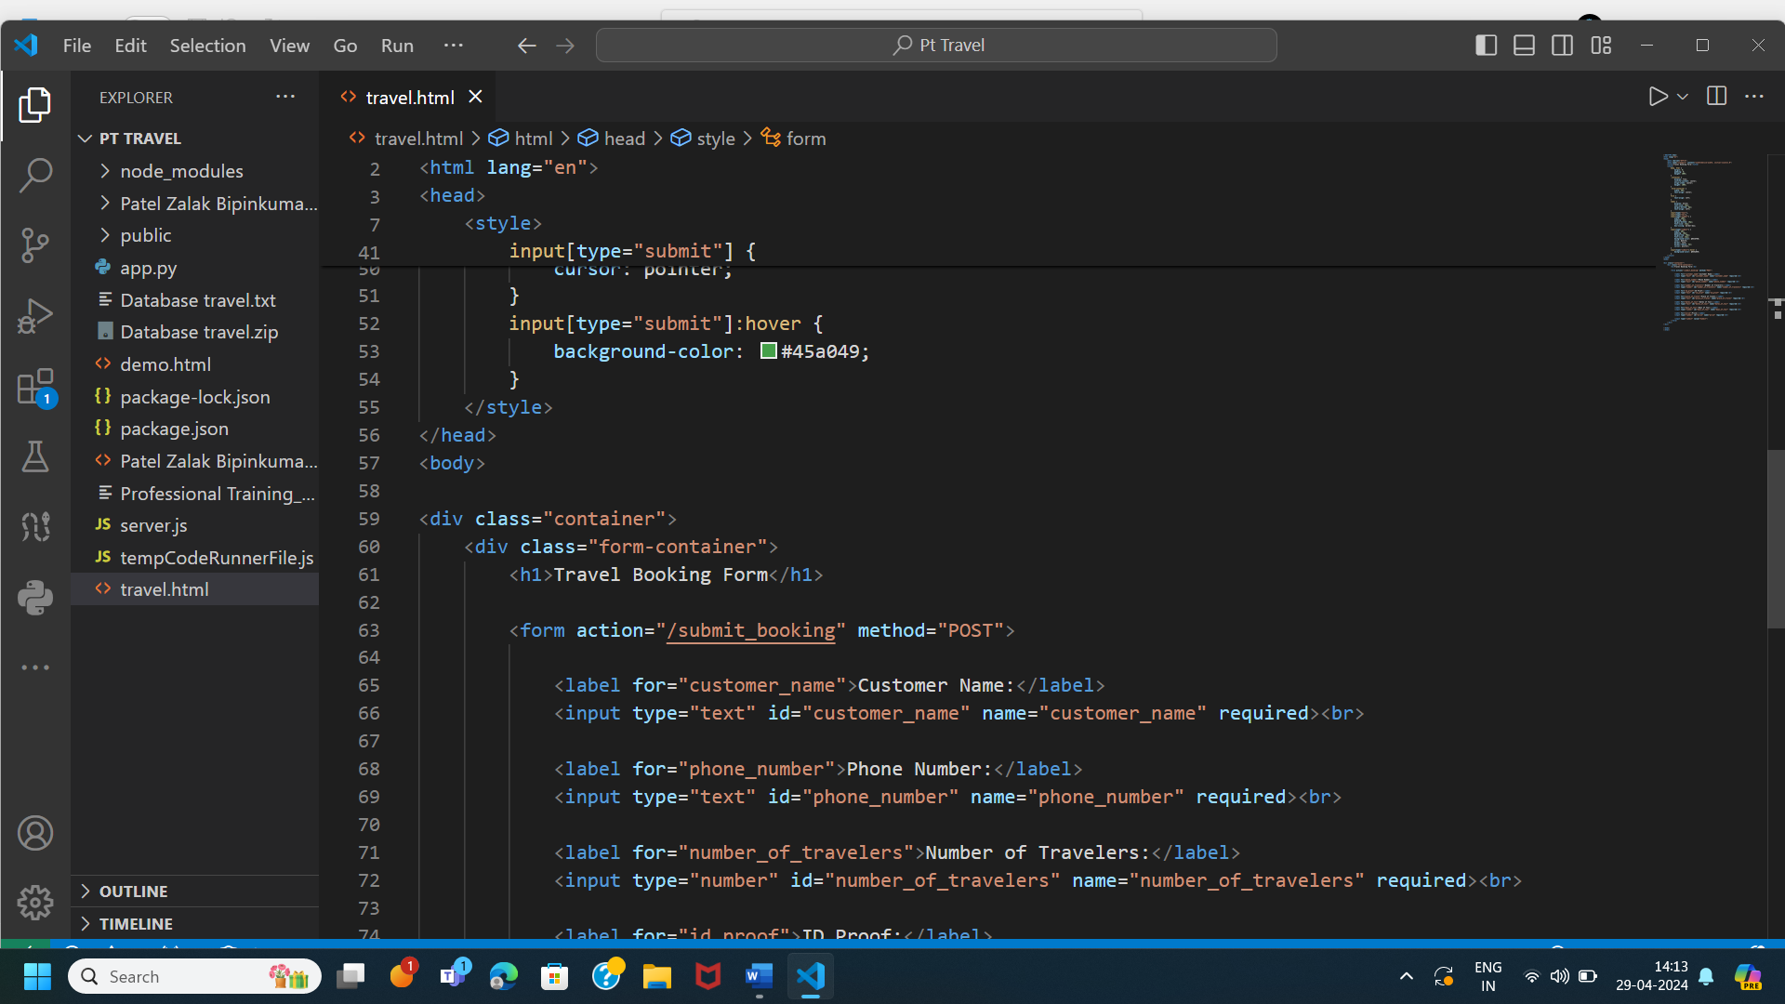

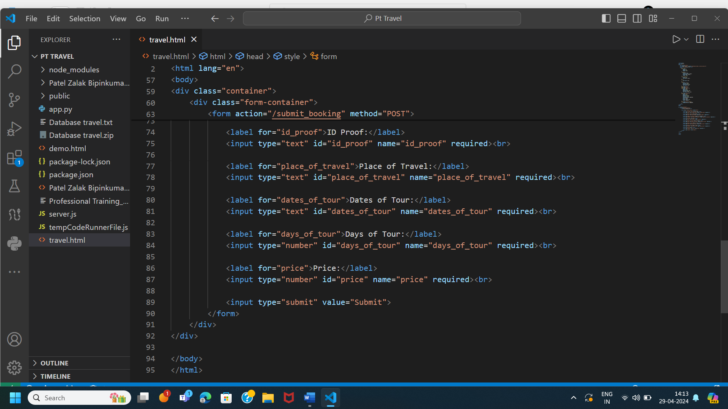

## 

## Backend:

For backend technology I have used MongoDB. Here is the connection code which I have done using node.js.

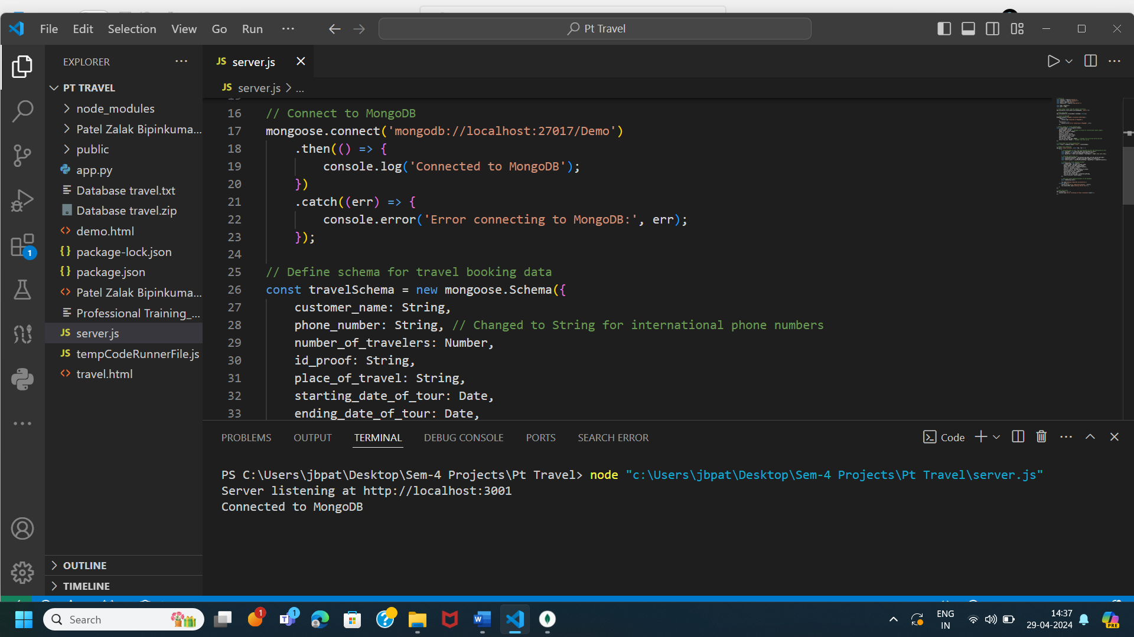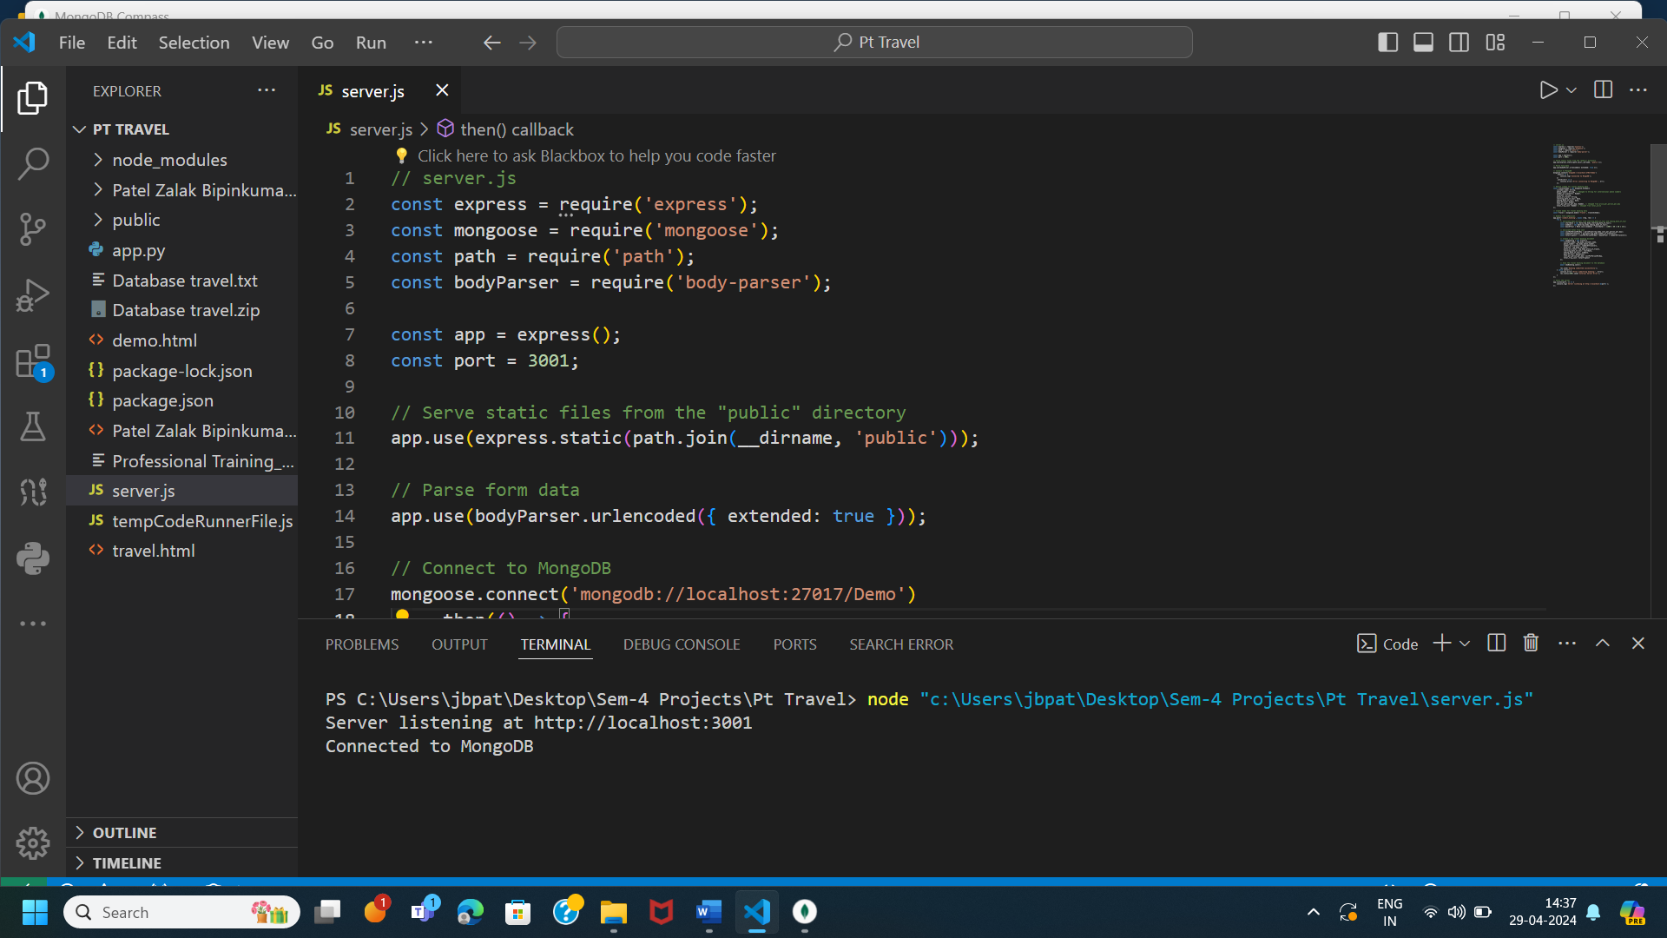

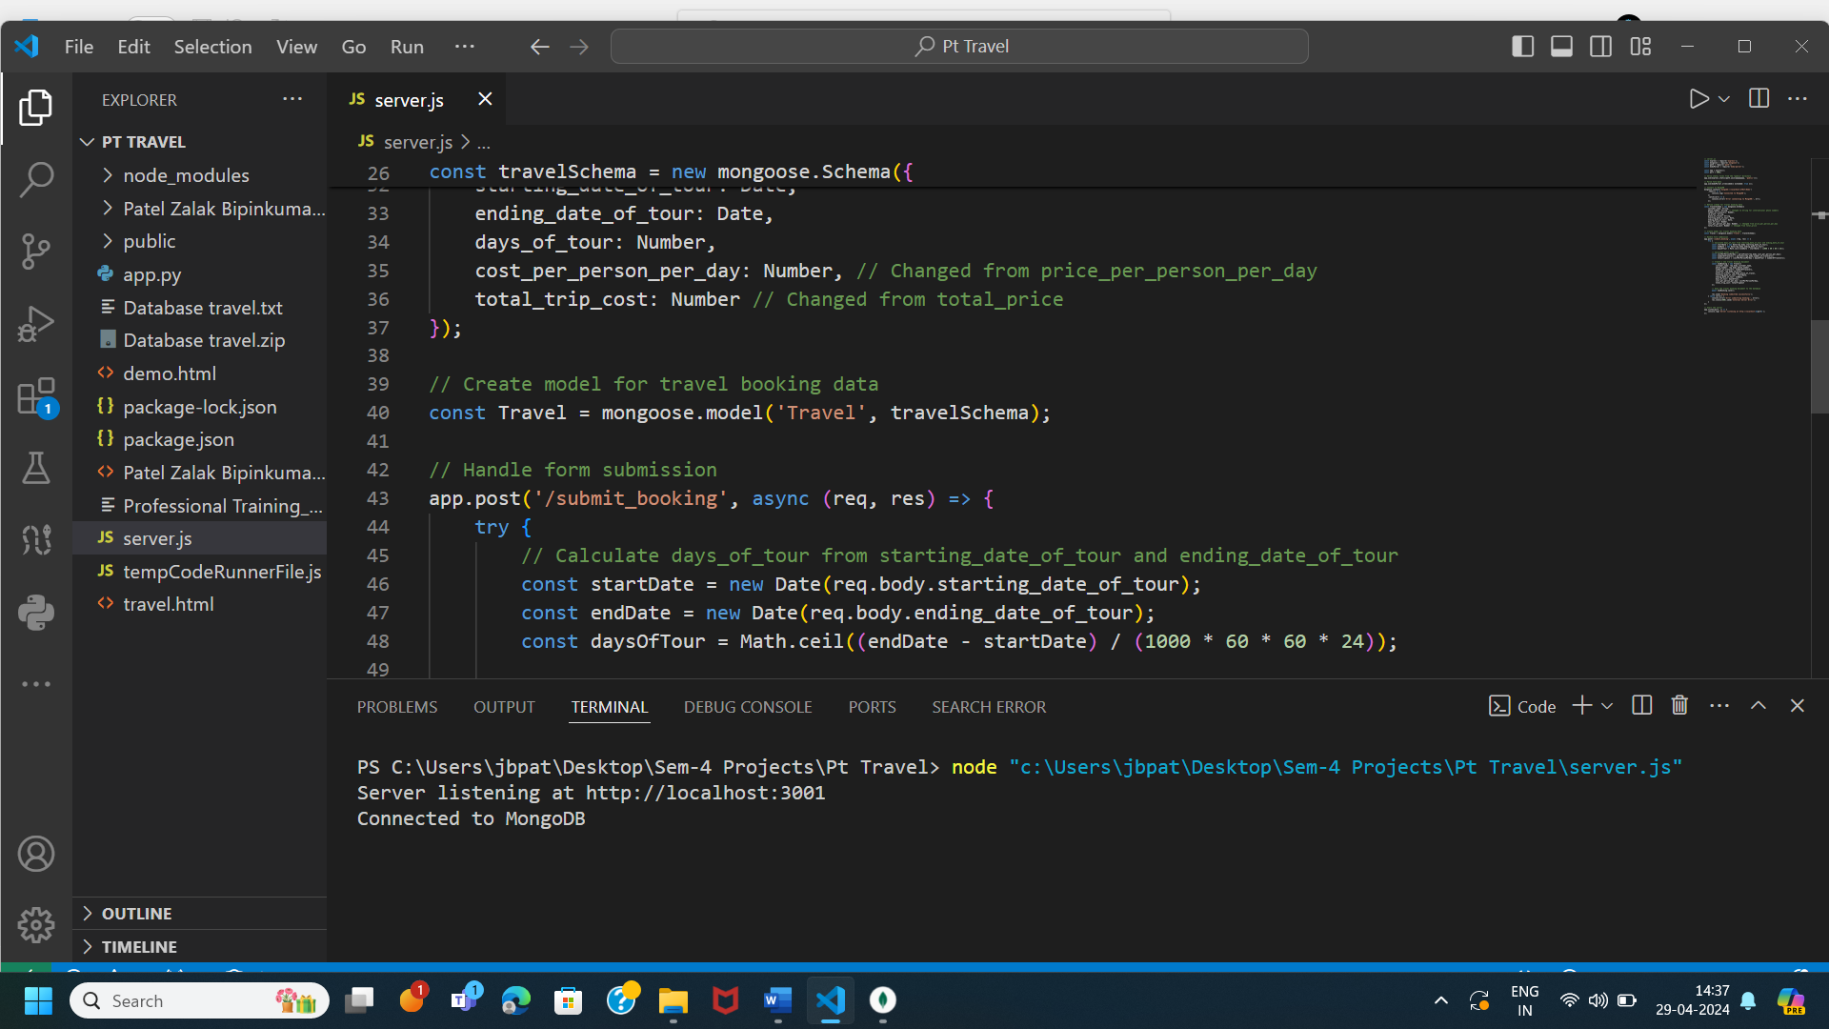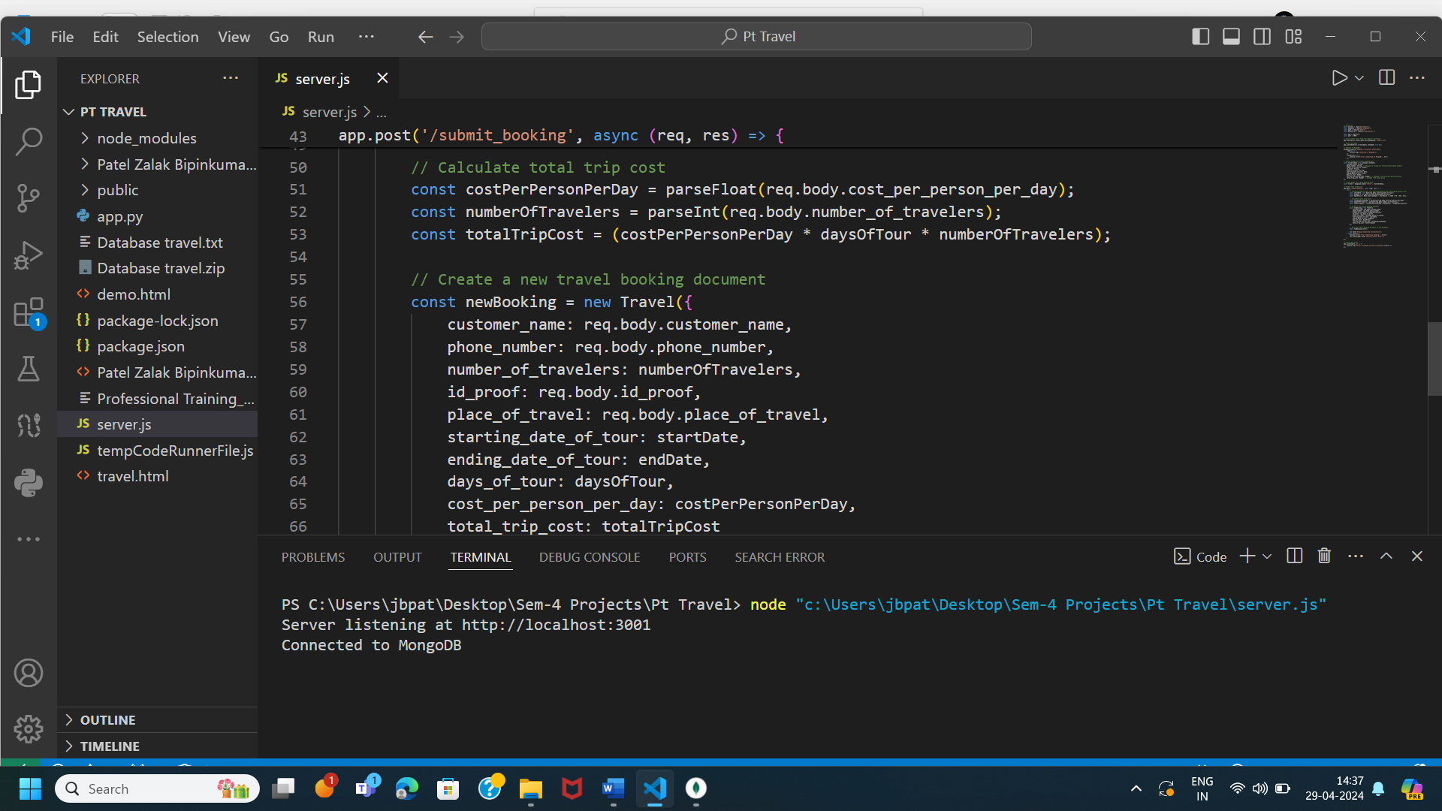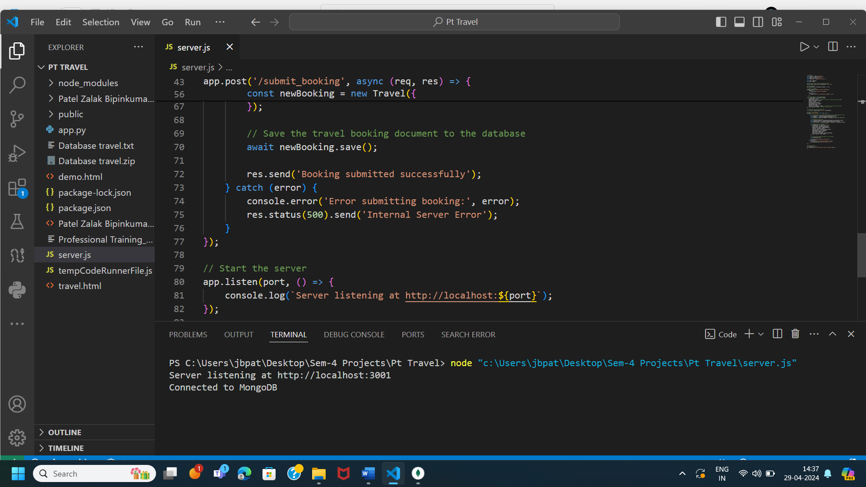

# FUNCTIONALITIES

Building a Webpage: Using HTML and JavaScript, a webpage is created in which Travellers data can be entered.

Database Integration: Here MongoDB is used for storing passangers records through integration.

Data entry: Including an application on the website that allows tour guides to directly enter travellers data into the database.

NodeJS : node.js is used to connect frontend and backend so node.js can also be called as connection bridge between web page and database.

Record Maintenance: insert and update feature can easily maintain information and records.

Booking Management: Gathering and storing passenger information in the database to assist with the booking process.

About Frontend Code:

In Frontend, for developing web page I have used different text fields such as name, phone number, id proof, number of travellers, place of travel, Starting date of tour, Ending date of tour, total days of tour, cost per person per day, total cost of trip, confirm submission and submit button.

In this fields there are some functionalities such as when I enter Starting date of tour and Ending date of tour then total number of days can be calculated automatically by using JavaScript. And also total cost can be calculated automatically with the help of depending parameters such as total number of days, number of travellers and cost per person per day.

# BENEFITS

Efficiency: Efficiency is maintained as it minimizes physical work of papers which also gives benefits as documents management can be done easily and efficiently.

Real-time Updates: Updates can be performed as we enter our data of travellers in frontend page it can be updated automatically in backend database.

Flexibility and accessibility is observed as one can book the tour from any corner of the world only with the help of internet connection.

Centralized Data: Data management is centralized when passenger records are kept in a MongoDB database. This facilitates information retrieval, updating, and analysis when needed.

Scalability: The scalability of MongoDB guarantees that the system can accommodate increasing amounts of passenger data without sacrificing efficiency, allowing it to grow to meet the demands of business.

# IMPLEMENTATION

Frontend code in which information of passenger is entered.

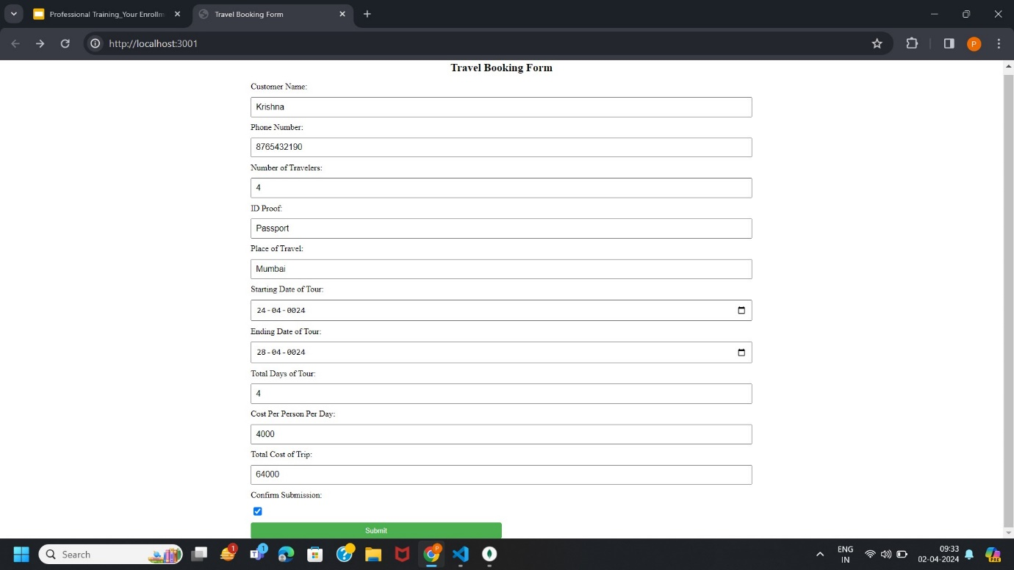

This message is seen after successful submission.

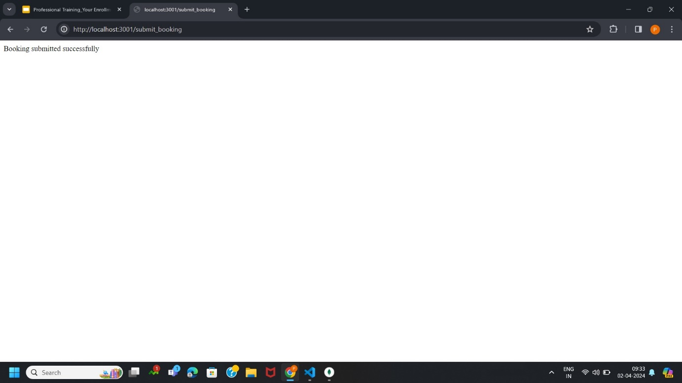

Glimpse of Backend database in which data is successfully stored.

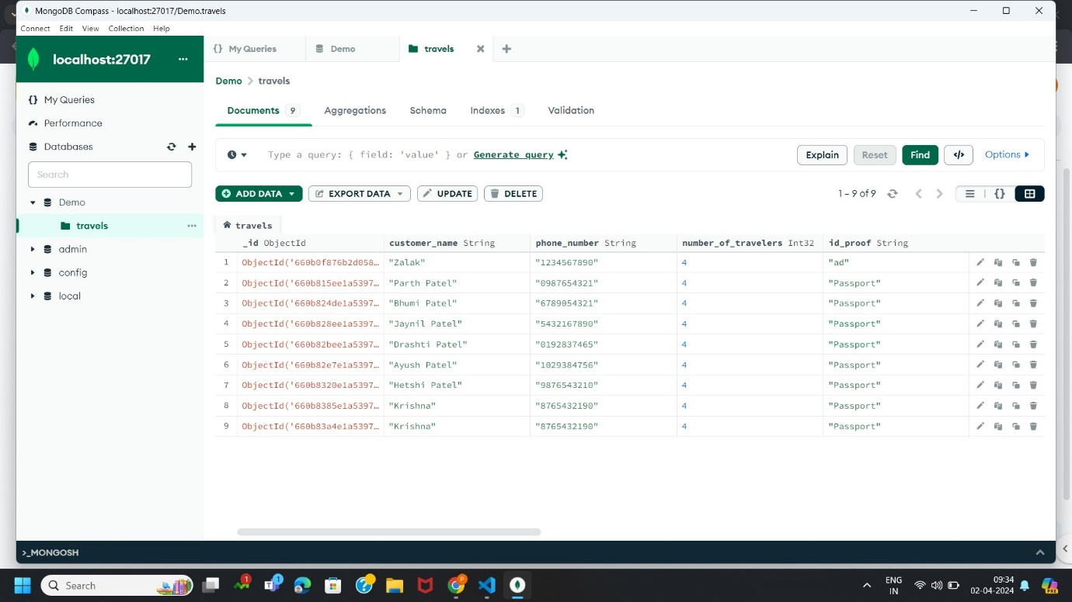

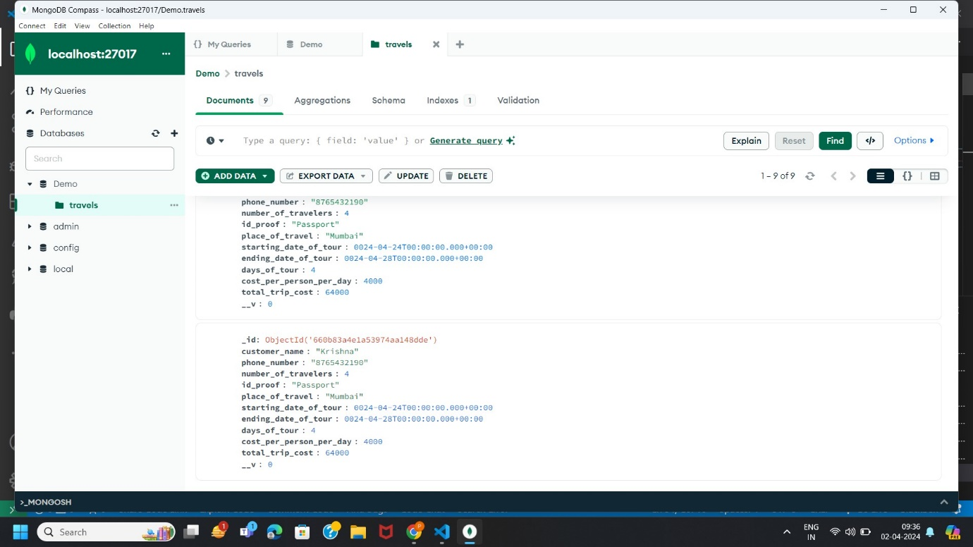

# CONCLUSION

To Conclude, it can be seen that online travel booking system with help of backend connectivity using node.js and MongoDB is efficient as it has many benefits such as maintaining records, booking easily, storing information etc. It provides guides with an interactive environment to discover places, personalize itineraries, and expedite the booking process by smoothly combining Node.js, HTML, JavaScript, and MongoDB. The system, with its focus on speed, comfort, and user-centric design, has the potential to completely transform how people plan their travel experiences in the digital era. With the ability to arrange travel in a personalized, easy, and accessible manner, it will enable consumers to transform their wanderlust into life-changing events.

# Oracle Academy Certificates

## Course Certificate

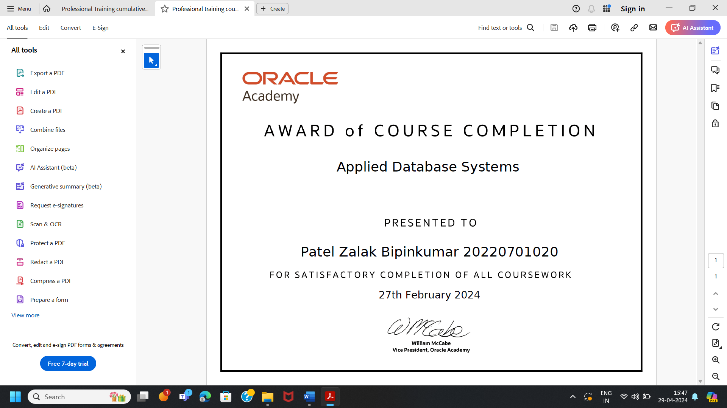

# Cumulative Exam Certificate

